INSTRUCTIONS FOR ACCESSING ONLINE HOOVER LIBRARY RESOURCES AT http://hoover.mcdaniel.edu or http://lib.hoover.mcdaniel.edu/home
OVERVIEW

Take advantage of the wealth Hoover Library online resources. Access them off-campus by simply logging in with your user name and password that you use for all other McDaniel College services.

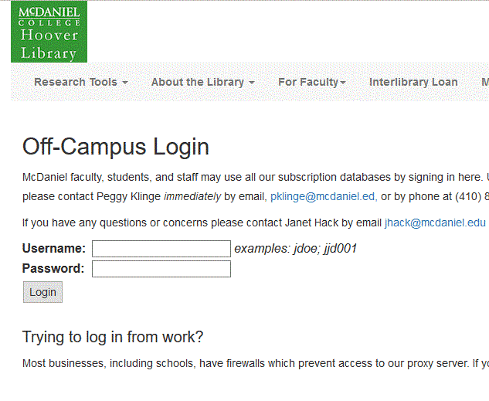

Databases that you will frequently be using:
- Horn Book Guide
- Wilson's Children’s Core Collections
- Wilson's Graphic Novels Core Collection
- Wilson's Middle and Junior High Core Collections
- Wilson's Nonbook Materials Core Collection
- Wilson's Senior High Core Collections
- Novelist

Journals that you will frequently be using:

- AASL’s Knowledge Quest
- Booklinks
- Booklist
- Horn Book Magazine (different than the guide!)
- Kirkus
- School Library Connection
- School Library Journal
- VOYA

If, after reading these instructions, you still need help, please:
- Text a librarian at: 410-346-5640
- Call a librarian at: 410-857-2281 or 410-857-2282
- Chat with a librarian at: http://ask.hoover.mcdaniel.edu
- See the Library Research Guides for School Librarianship

DATABASE INSTRUCTIONS FOR WILSON’S
You may search by title, by subject, or other ways when you click on the Advanced Search.
- Go to http://hoover.mcdaniel.edu.
- Click on A-Z database list.
- Go to bottom of list and choose Wilson’s Children’s Core Collections.
- Insert your McDaniel College user name and password.
- Click on Advanced Search.
- Find all the options, but select option “Most Highly Recommended” and then insert the title of the book.
- If it is not listed as “Most Highly Recommended” then select another title to read. Wilson’s gives you two other recommendation levels—the Core Collection and the Archival one.
- See the following two screen shots.
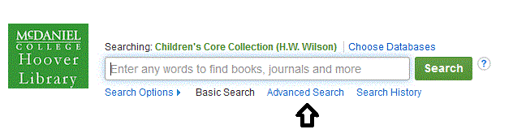
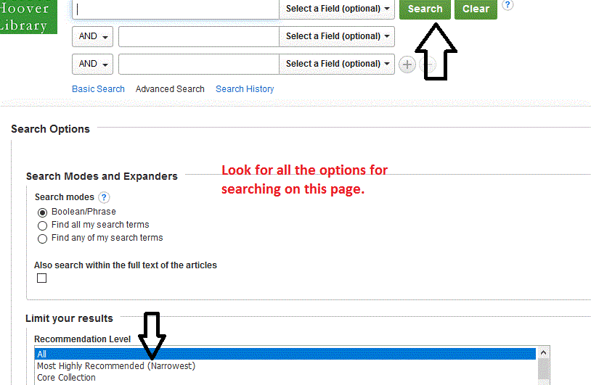

DATABASE INSTRUCTIONS FOR HORN BOOK GUIDE ONLINE
- Go to http://hoover.mcdaniel.edu.
- Click on A-Z database list.
- Go to bottom of list and choose Horn Book Guide Online. The instructions are easy to follow, but please let us know if you have trouble. Remember that the Guide is NOT the same as the Horn Book Magazine.

DATABASE INSTRUCTIONS FOR NOVELIST
- Go to http://hoover.mcdaniel.edu.
- Click on A-Z database list.
- Select NovelList.

INSTRUCTIONS FOR ACCESSING JOURNALS
- Go to http://hoover.mcdaniel.edu.
- On the left menu bar, click on “Find Journal by Title.”
- Insert the title of the journal.
- For each journal, click on the month and year that of the journal you want.
- Then look on the left side and select “reviews.”
- Or, you may choose the option “Search Within this Publication” and then “Advanced Search.”
- See screen shots:
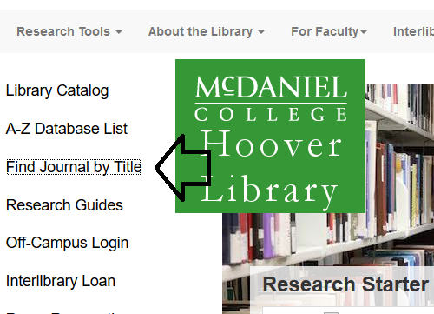

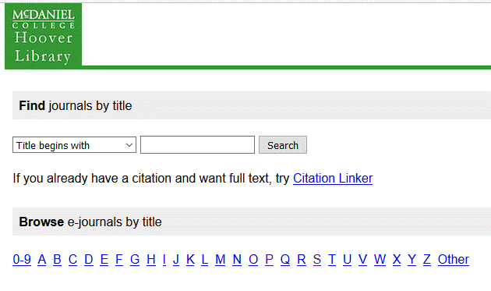
If you are already logged in to Hoover Library, here are some direct links to the journals.
Booklist http://uv7ae8sy4y.search.serialssolutions.com/log?L=UV7AE8SY4Y&D=ESX&J=BOOKCHILL19&P=EJP&PT=EZProxy&U=https%3A%2F%2Fhoover2.mcdaniel.edu%3A2443%2Flogin%3Furl%3Dhttp%3A%2F%2Fsearch.ebscohost.com%2Fdirect.asp%3Fdb%3Da9h%26jid%3DBLL%26scope%3Dsite
Horn Book Magazine http://uv7ae8sy4y.search.serialssolutions.com/log?L=UV7AE8SY4Y&D=ESX&J=THEHORBOOMA&P=EJP&PT=EZProxy&U=https%3A%2F%2Fhoover2.mcdaniel.edu%3A2443%2Flogin%3Furl%3Dhttp%3A%2F%2Fsearch.ebscohost.com%2Fdirect.asp%3Fdb%3Da9h%26jid%3DHBM%26scope%3Dsite
Knowledge Quest http://uv7ae8sy4y.search.serialssolutions.com/log?L=UV7AE8SY4Y&D=ESX&J=KNOWQUE&P=EJP&PT=EZProxy&U=https%3A%2F%2Fhoover2.mcdaniel.edu%3A2443%2Flogin%3Furl%3Dhttp%3A%2F%2Fsearch.ebscohost.com%2Fdirect.asp%3Fdb%3Da9h%26jid%3D5F8%26scope%3Dsite
Kirkus
http://uv7ae8sy4y.search.serialssolutions.com/log?L=UV7AE8SY4Y&D=ESX&J=KIRKREV&P=EJP&PT=EZProxy&U=https%3A%2F%2Fhoover2.mcdaniel.edu%3A2443%2Flogin%3Furl%3Dhttp%3A%2F%2Fsearch.ebscohost.com%2Fdirect.asp%3Fdb%3Da9h%26jid%3DIZ4%26scope%3Dsite
School Library Journal http://uv7ae8sy4y.search.serialssolutions.com/log?L=UV7AE8SY4Y&D=ESX&J=SCHOLIBJOUN&P=EJP&PT=EZProxy&U=https%3A%2F%2Fhoover2.mcdaniel.edu%3A2443%2Flogin%3Furl%3Dhttp%3A%2F%2Fsearch.ebscohost.com%2Fdirect.asp%3Fdb%3Da9h%26jid%3DSLJ%26scope%3Dsite
ACCESS YEARLY CALDECOTT AND NEWBERY SPEECHES
- Search Horn Book Magazine.
- Select year that you want.
- Select July/August issue; Caldecott and Newbery speeches are always printed in that issue.

